**PROJECT – STATEMENT OF WORK**

**Project Details:**

| Team | Tableau_Project_Team_10 |
| --- | --- |
| Project Start Date | 19th July, 2021 |
| Company | Innodatatics |
| Project Title | Baggage Handling System |
| Domain | Aviation |
| Draft Version | 1 |
| Contributor(s) | - |

**Overview:**

A Baggage Handling System (BHS) is a type of conveyor system that transports checked luggage from ticket counters to areas where the bags can be loaded onto [airplanes](https://en.wikipedia.org/wiki/Airplane). A BHS also transports checked baggage coming from airplanes to baggage claims or to an area where the bag can be loaded onto another airplane.

A bag is entered into the Baggage Handling System (BHS) when an airline agent, or self-check system, assign the luggage a tag with a unique ten digit [barcode](https://en.wikipedia.org/wiki/Barcode). The BHS will then scan and sort the bags by airline. Then a series of diverters along the conveyor belt will direct the bags into the baggage handling area.

At the handling area, the baggage passes through a security check which comprises three levels i.e., L1, L2 and L3. At every level, numerous operations will be performed on the baggage and different parameters such as the decision time and status (delay, missing of baggage) is observed. Based on the status at a particular level, the baggage will be forwarded to the next level.

Although the primary function of a BHS is the transportation of bags, a typical BHS will serve other functions involved in making sure that a bag gets to the correct location in the airport.

**Objectives:**

The main objective is to reduce the baggage inspection time taken at each security level and to minimize the number of mishandled bags, by improving operational efficiency in baggage handling.

**Constraints:**

Due to increase in baggage, overloading of the system may occur. Hence, volume regulation and load balancing are necessary.

**Sequential Steps:**

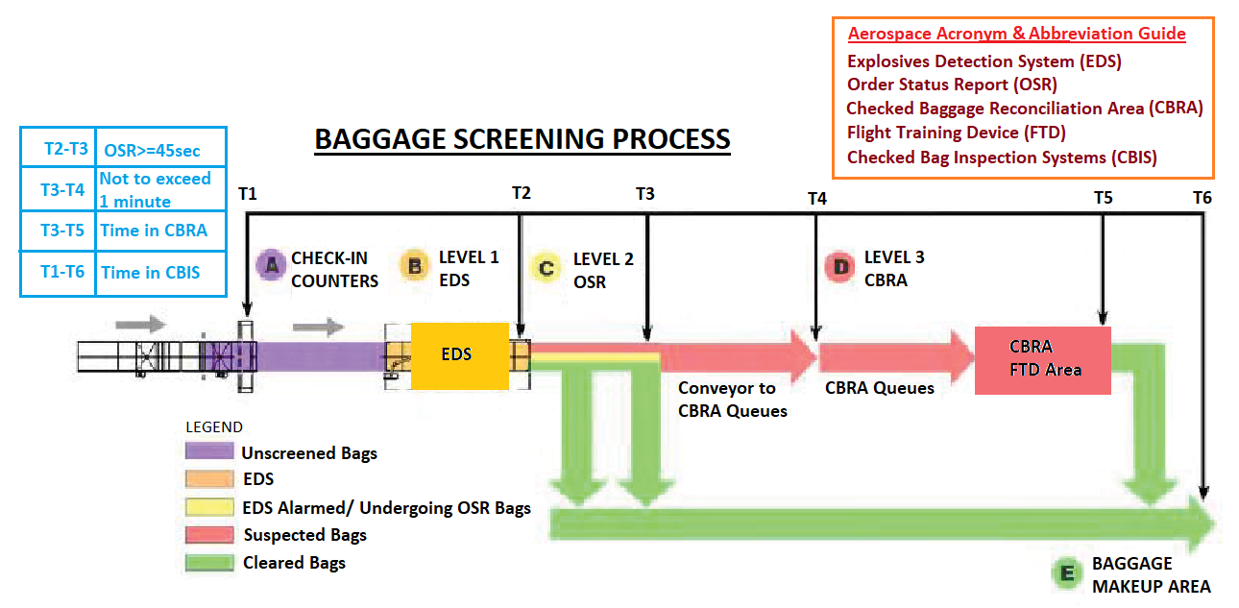

**Dataset Understanding:**

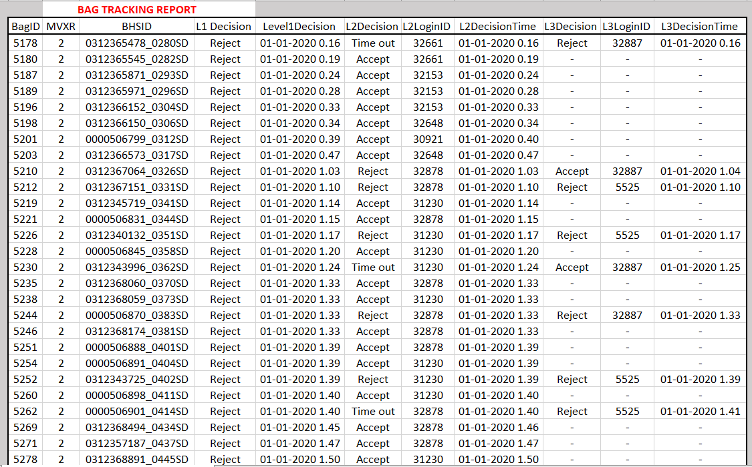

* The baggage with a baggage ID and a unique BHSID is passed through three levels L1, L2 and L3 based on the status at a particular level.
* The baggage will be scanned using any 4 of the Multi View X-Ray (MVXR) Scanners installed already for L1 & L2 checking.  L3 is manual checking if anything is found out to be suspicious in L1 / L2 scanning.
* L1 Decision groups the status as ‘-’ or ‘Reject’.
* L2 Decision groups the status as ‘Accept’, ‘Default Reject’, ‘Reject’ or ‘Time Out’.
* L3 Decision groups the status as ‘-’, ‘Accept’, ‘Default Reject’, ‘Reject’ or ‘Time Out’.
* The L1, L2 and L3 Decision enables us to understand whether the baggage is stopped or moved to the next level by showing the level in which the baggage is currently present.
* The L1, L2 and L3 Decision Time enables us to understand whether the baggage is delayed or not in the process of checking and helps the passenger to understand tracking of baggage.
* Final Status after scanning all bags

| **Final Status** | **Final Count** | **Decision L1** | **Decision L2** | **Decision L3** |
| --- | --- | --- | --- | --- |
| - | N/A | 2533 | N/A | 812741 |
| Accept | 961,774 | - | 812,741 | 149033 |
| Reject | 81713 | 1046041 | 179,968 | 81713 |
| Default Reject | 1918 | - | 33,384 | 1918 |
| Time out | 3169 | - | 22481 | 3169 |
| Total | 1,048,574 | 1,048,574 | 1,048,574 | 1,048,574 |

**Software/ Tools:**

* Tableau Desktop

**Project Milestones:**

| **Tasks** | **Deadline** |
| --- | --- |
| Project Charter |  |
| First draft report preparation |  |
| Worksheet preparation and observation |  |
| Dashboard preparation |  |
| Final report and project closure |  |

**Deliverables:**

Presenting interactive dashboards for

* The Baggage ID along with Levels
* Time taken for the baggage to complete the security check
* A running dashboard for checking the current status and location of the baggage at a glance.

**Necessary Approvals**

* Client
* Project Manager
* Team Leader